

**Preemadonna Maker Kit Instructions**

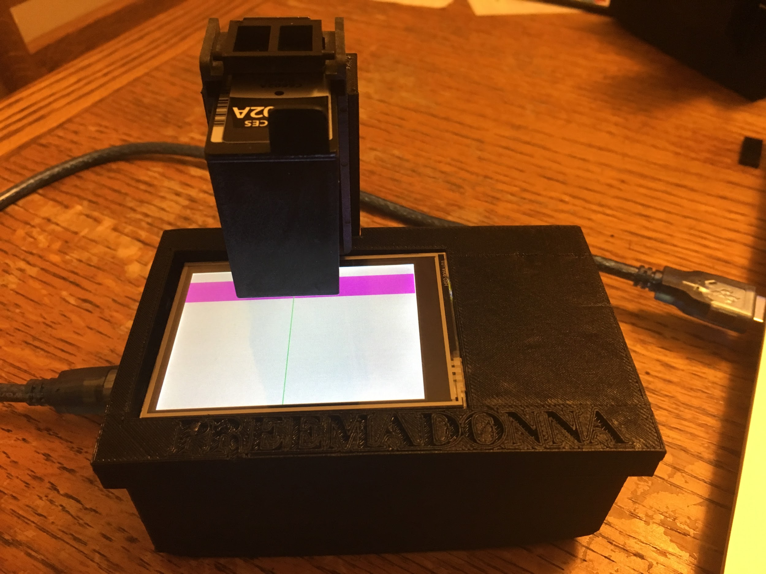

Assembly:

1. Plug the inkshield into the arduino.
2. Plug the shield stacking headers into the inkshield.
3. Plug the touchscreen into the stacking headers.

The results should look like this.

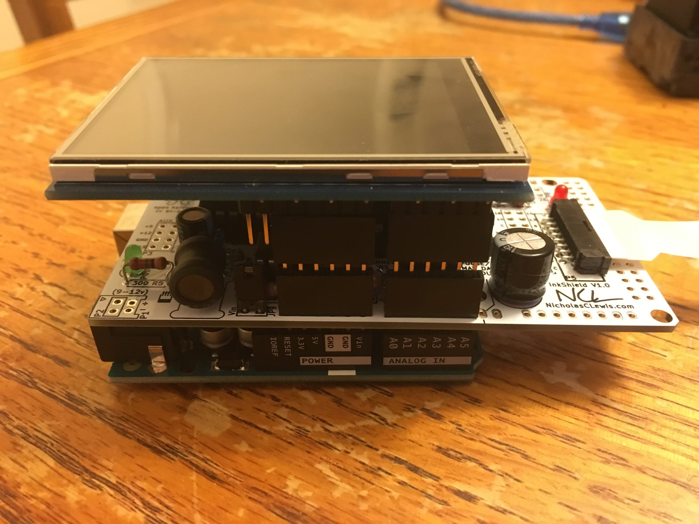

1. Load the inkjet cartridge into the carrier.
2. Feed the flat cable from the cartridge carrier into the bottom of the housing.

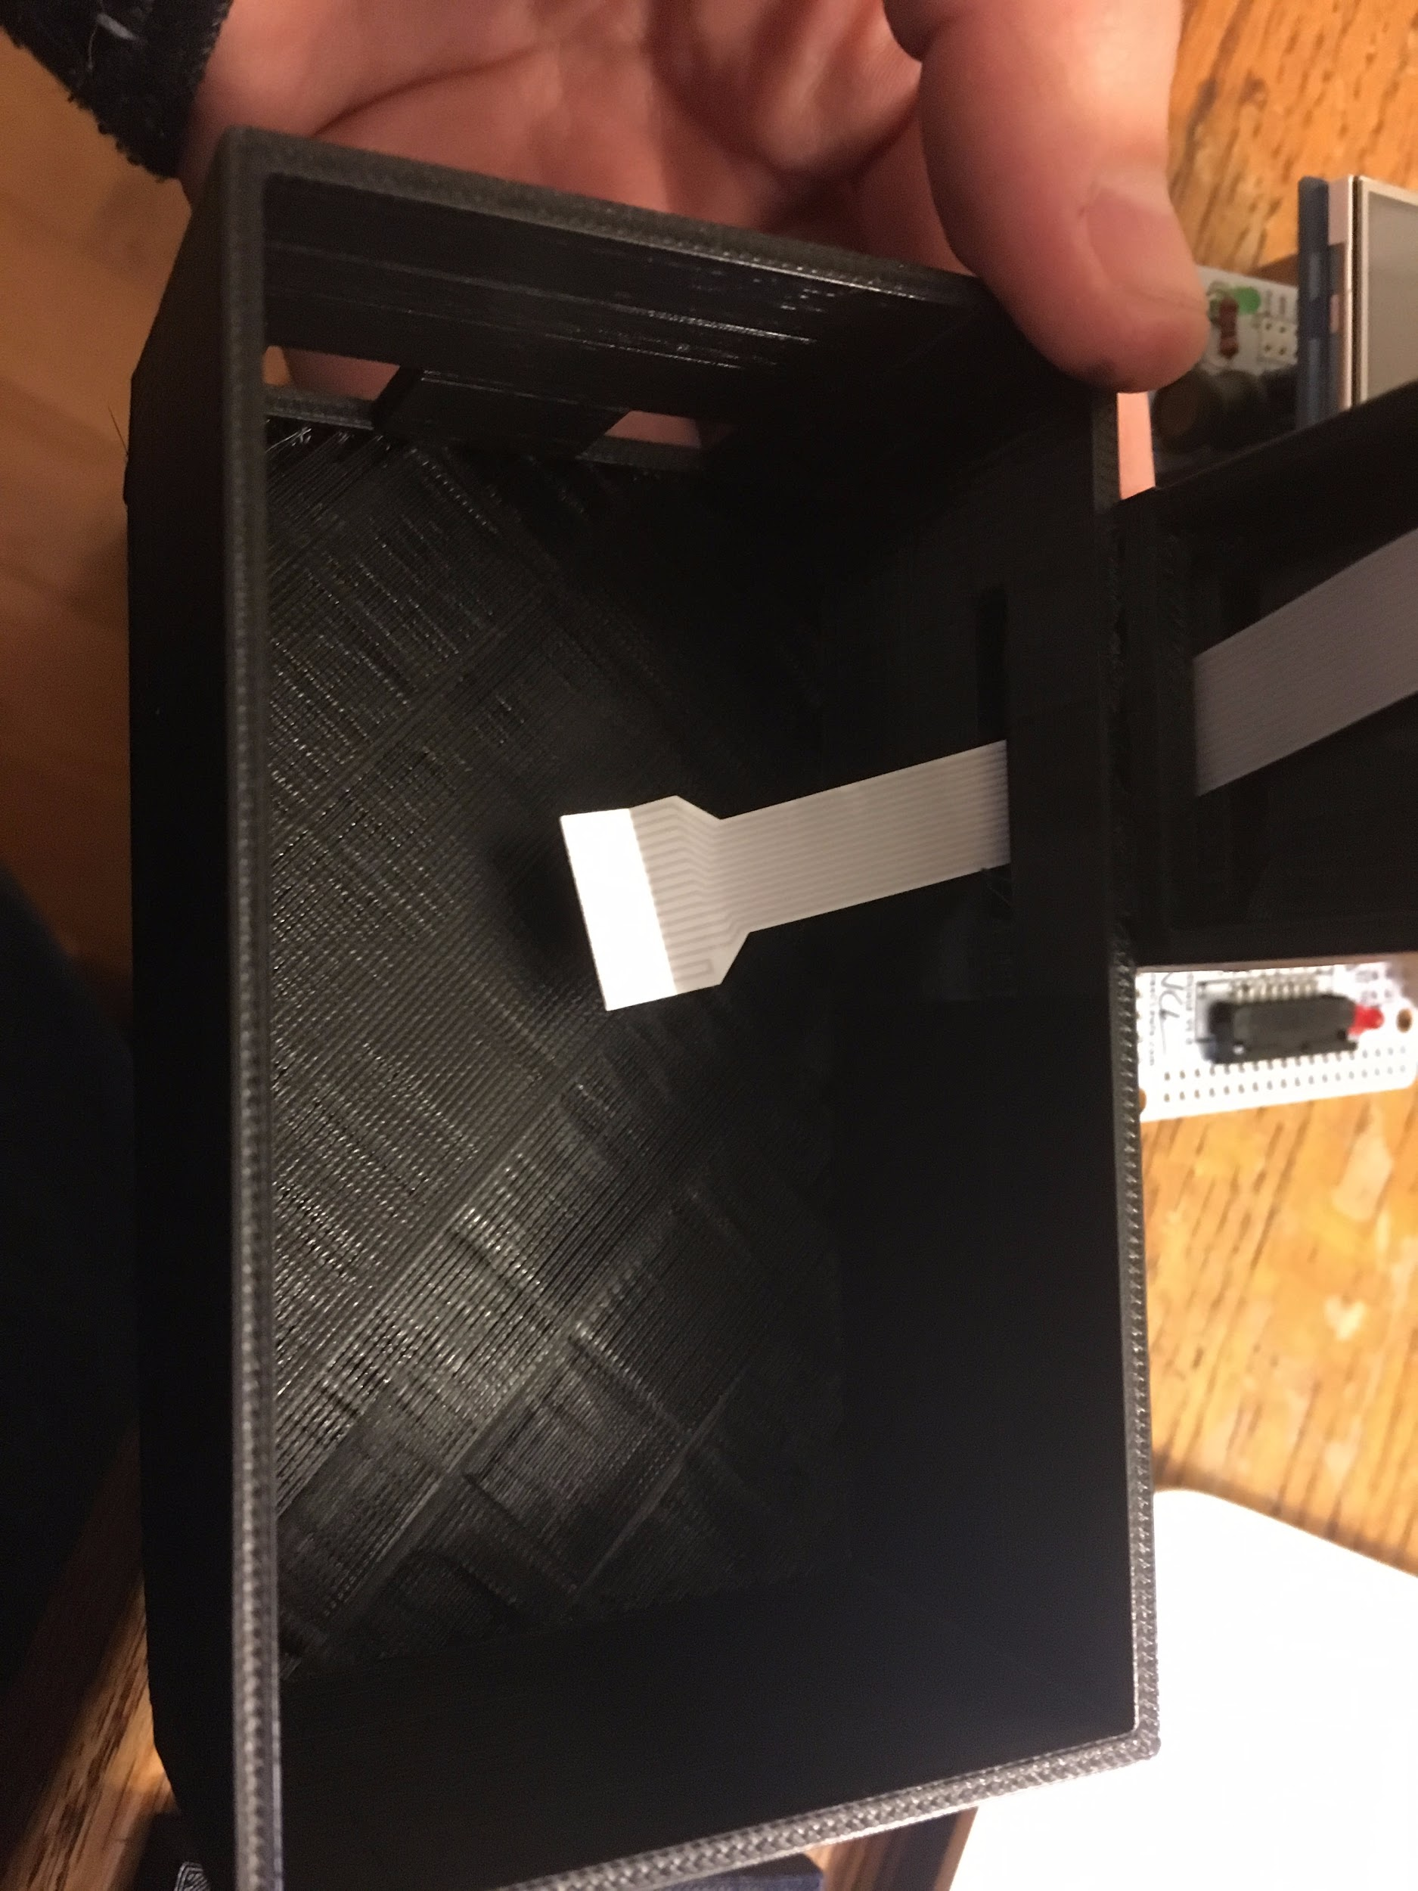

1. Plug the flat cable into the side of the inkshield board with the metal contacts pointed down.
2. Load the whole assembly into the bottom of the housing.
3. Put the top onto the housing.
4. Lower the cartridge assembly into place, feeding the flat cable into the housing.

Understanding the code

The code includes a number of sections. The first section loads all necessary libraries, initializes various components, and is where the design to be printed is coded. The 2nd section sets up the arduino. The 3rd section is the main loop which continuously runs. The 4th section is a subroutine that actually commands the printing.

If you are unfamiliar with arduino programming, please visit <https://www.arduino.cc/en/Tutorial/Foundations> to learn more.

This code uses a variety of libraries (provided by Preemadonna), which must be loaded onto your computer. Drag the library folders into your libraries folder. Under Windows, it will likely be called "My Documents\Arduino\libraries". For Mac users, it will likely be called "Documents/Arduino/libraries". On Linux, it will be the "libraries" folder in your sketchbook.

Preemadonna provides the initial sample code MakerKit.ino. This allows you to focus on adding your flair to the screen graphics and printed designs.

## 1st Section: Loading Libraries, Initializations, and Design

### Loading libraries:

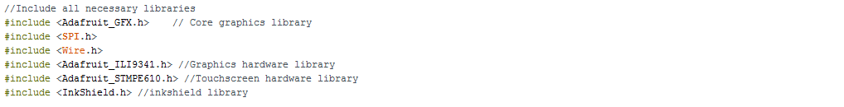

### Touchscreen Initializations

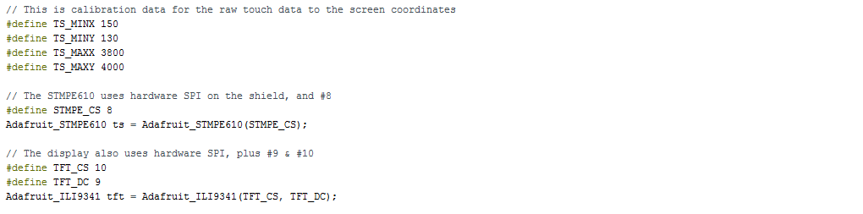

### Inkshield and Design Initializations

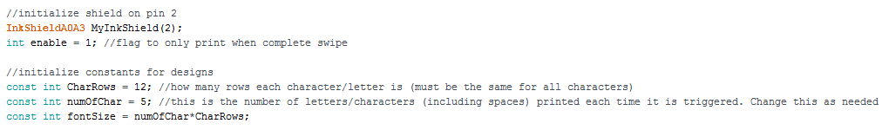

For this section, the CharRows and numOfChar will change depending on your design. For more details on how the design is implemented, see below.

### Coding the design

The design is coded in sections that define each character (including spaces). The designs are 12 columns long (the number of nozzles in the print head) and any number of rows. The number of rows in each character has to be the same. The example types out the design below

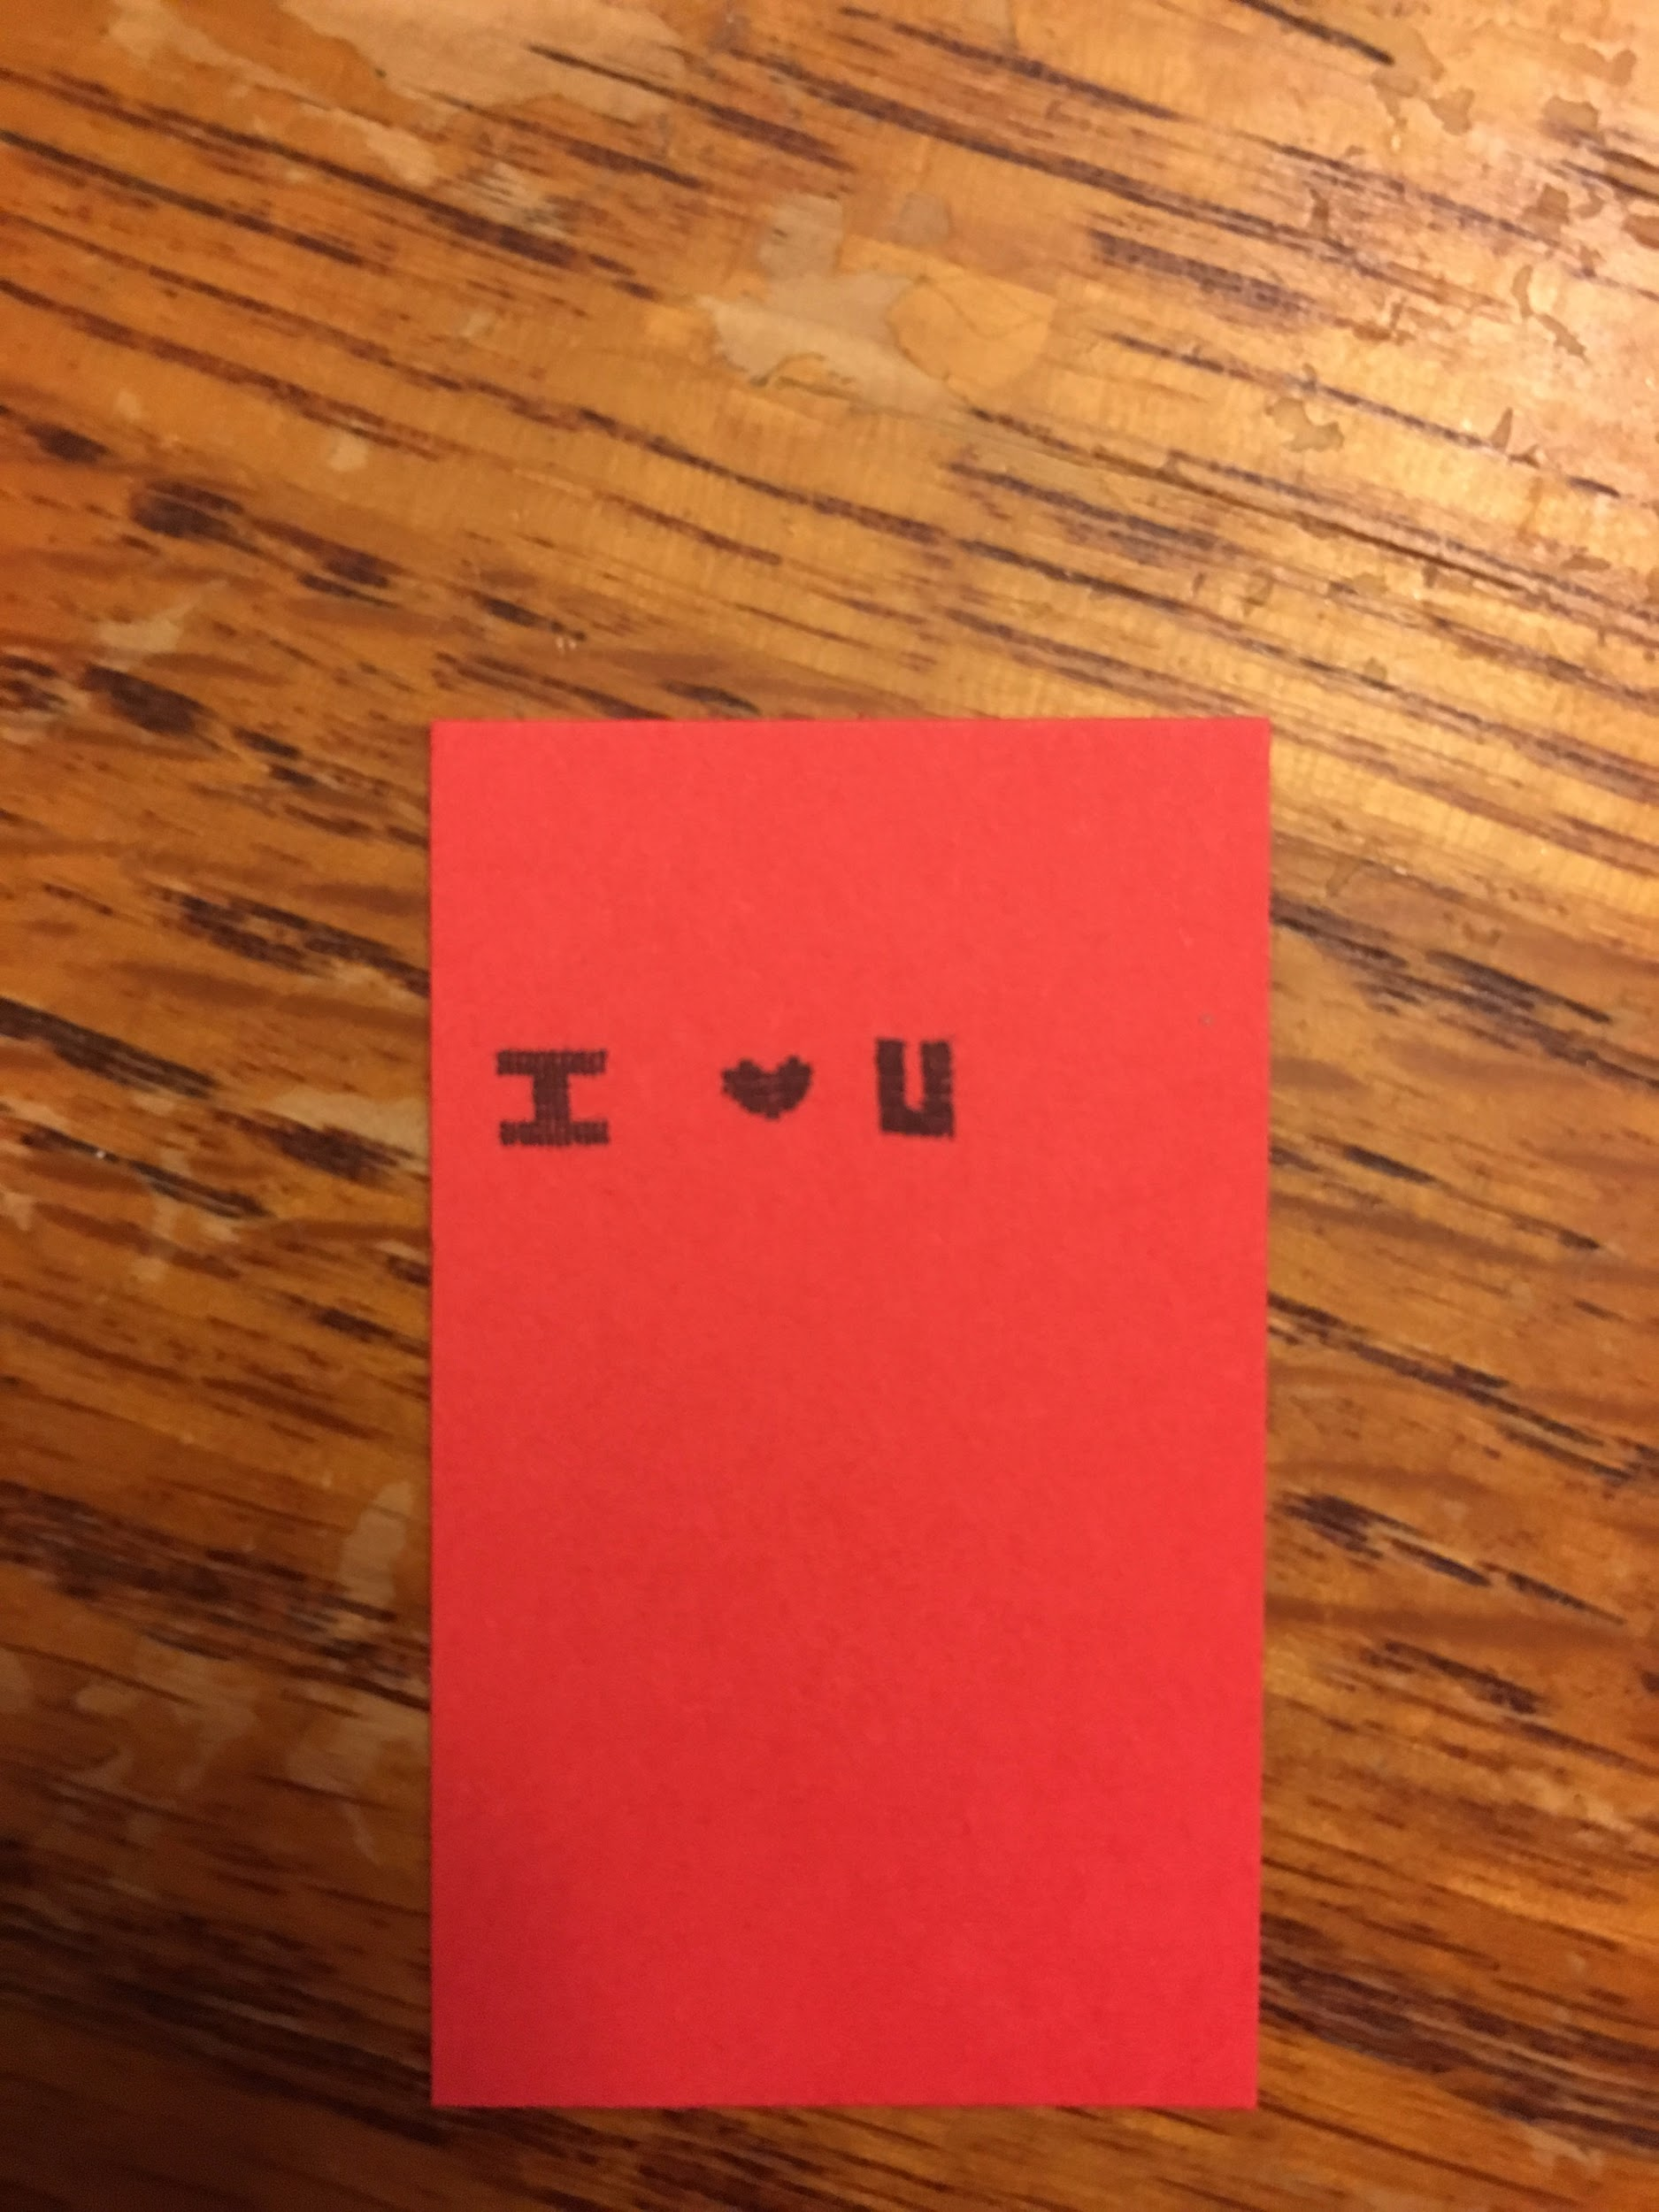

The designs are represented as 1s and 0s. A 1 means that the nozzle is fired and thus ink is dispensed, while a 0 means it is not. An inkjet expels a drop of ink by heating a resistor which causes a small bubble to form inside the nozzle and push a drop of ink out the nozzle. For information on how the inkshield sends the necessary signals to the print head, see <http://nicholasclewis.com/projects/inkshield/theory/>

Due to the orientation of the printhead and the direction of the swipe, the design is coded sideways. So in the code the design looks more like this



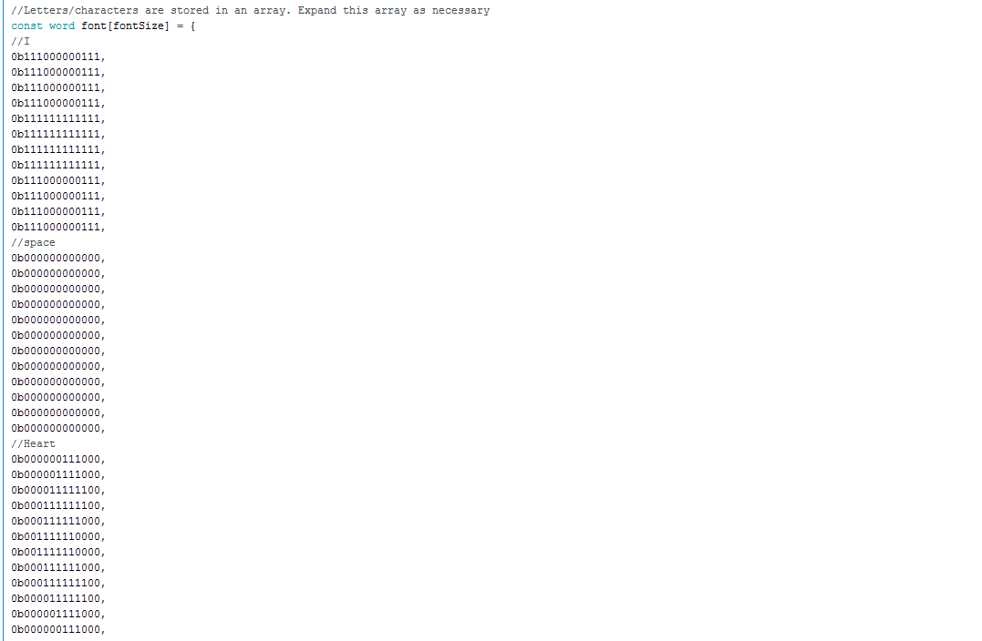

## 2nd Section: Setup

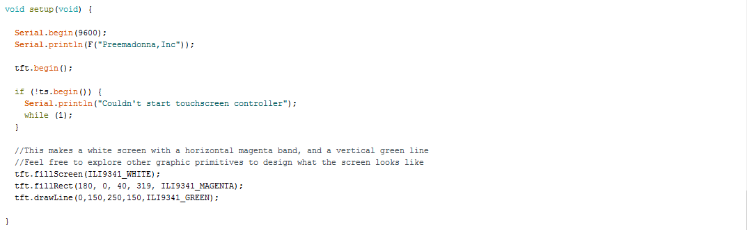

The first part of this section sets up serial communication. The 2nd part draws what will appear on the touch screen. In the example provided the screen is filled with white. Then a horizontal magenta band is drawn. Finally a green vertical line is drawn. The magenta band and green line indicate where the nozzles on the inkjet cartridge are.

This graphics setup section is a great place to add your own flair. Feel free to make creative designs to display during use. For more information on the types of graphical primitives you can design, see <https://learn.adafruit.com/adafruit-gfx-graphics-library/graphics-primitives>

## 3rd Section: Main Loop

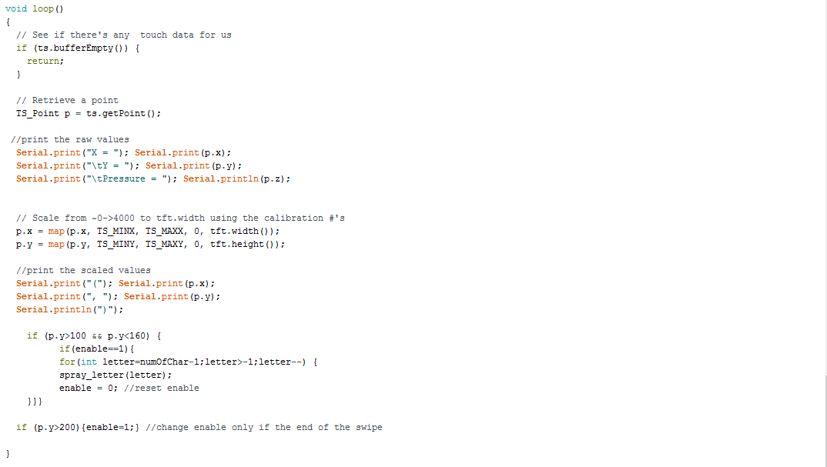

This section will continuously loop while power is supplied to the board. First, the code checks to see if there is any data from the touchscreen. Then it reads the data from the touchscreen. The data it reads is the X,Y, and pressure. If the arduino is plugged into the computer and the serial port is being monitored  then the computer will show the data. Next the code scales the raw data to fit the size and number of pixels in the screen (which was defined in the initializations). If a computer is connected to the arduino, it will also print the scaled X,Y location.

The magic of the code is the first if loop. It checks to see if the y location is in the trigger zone. If it is, then it prints the design. If it is not it goes back to the top of the main loop and goes again. The 2nd if loop is an enable function. This makes it so that you have to do a full swipe for the code to reset itself for the next print. If the enable function is not present then anytime the y location is in the trigger zone it will continuously spew the design and result in a puddle of ink.

## 4th Section: Print Loop

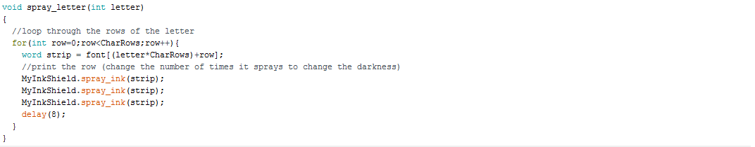

This section uses the functions in the inkshield library to loop through each row of each character of your design to print the image. If you want a darker image you can copy the spray_ink command again. For a lighter image, reduce the number of times the spray_ink command is used.

Cartridge Care

The ink in the nozzles can easy dry up. This causes the nozzle not to spray a drop of ink. If this happens, simply take a kleenex and wipe sideways across the nozzles until you get a consistent dark spot of ink when you wipe.

If the cartridge is not going to be used for a while, remove it from the printer and snap the orange cover back on. This protects the nozzles from air exposure and will ensure the cartridge lasts longer.

Design Template

